**Declaration of Originality**

Subject: Project in Computer Science for Engineers (WS 2020/2021)

We

Name 1: Joshua Hertel

Name 2:

Name 3:

Michael Schwenkschuster Tan Jia Tian

affirm that

* we wrote this lab report by ourselves as a team;
* we all were involved to an approximately similar extend in the lab work;
* we as authors all know and agree about the content of this submission;
* we did not use other than the denoted sources and aids;
* we have identified all textual and analogous sites for the report.

Signing this declaration means that you are not allowed to plagiarize, nor identify a student as co-author, if he/she did not participate actively in carrying out the lab experiment and writing the report.

Doing so, is a serious scientific misconduct and will lead to the fact that the whole team will not pass the lab.



Signature Name 1

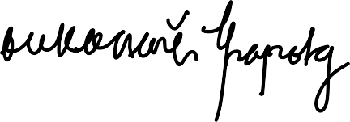

Signature Name 3

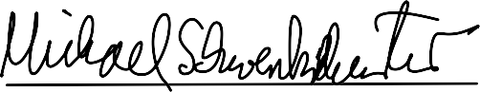

Signature Name 2